CODESQUAD · CLIENT CASE STUDY
Harmony Med Spa
Patient Growth System

One connected system: Google Ads, landing pages, CRM, automated follow-up, booking, SEO content, and reporting — all in one place.

Sarasota, Florida · Prepared by CodeSquad · September 2026

OVERVIEW

What we deliver for Harmony

Four service areas, all connected, all running today.

# | Service area | What it covers
1 | Google Ads → CRM → Booking | Treatment-based campaigns, landing pages, lead capture, instant follow-up, 14-day nurture, PatientNow booking
2 | Blog & content | SEO, AEO and GEO articles written and published through the CRM
3 | CRM & website | Custom dashboard and website development and ongoing maintenance
4 | Google Business Profile | Reviews, replies, posts and local analytics

The patient journey
1. Google Ads — treatment-based campaign
2. Patient clicks the ad and enters the enquiry
3. Treatment-specific landing page and form
4. Lead goes into the CRM with full attribution
5. Speed-to-Lead — instant SMS + email
6. 14-Day Campaign if there is no response
7. Appointment booked in PatientNow
8. Google Analytics and reporting inside the CRM

Live numbers
From Harmony’s dashboard, last 90 days.

3s  SPEED TO LEAD | 159  MESSAGES SENT | 96%  SMS DELIVERY | 100%  EMAIL DELIVERY

24,560  IMPRESSIONS | 1,044  CLICKS | 4.25%  CTR | $2.08  AVG CPC

32  LEADS NURTURED | 150  NURTURE MESSAGES | 21  SEO ARTICLES | 2  LIVE CAMPAIGNS

SERVICE 1 · STEP 1

Google Ads — treatment-based campaigns

- Campaigns by treatment. A separate campaign per treatment, so weight loss, injectables and skin treatments each get their own budget, ads and landing page.
- Local targeting. Sarasota-area only. No budget spent on people who will never visit the clinic.
- Intent keywords. People actively searching for a treatment or provider, not casual browsers.
- Negative keywords. 44+ terms blocking competitors, job seekers, DIY searches and out-of-area cities before they cost anything.
- Ad testing. Multiple ad variations per ad group so the best-performing message wins on data.
- Conversion goals cleaned. Only real lead events count. The account previously counted 11 actions equally, including Google micro-actions, which corrupted automated bidding.
- Policy compliance. Health-advertising rules followed strictly. A disapproved ad is a campaign that stops running.

Currently running: 7 campaigns · 13 ad groups · 36 live ads · 121 keywords.
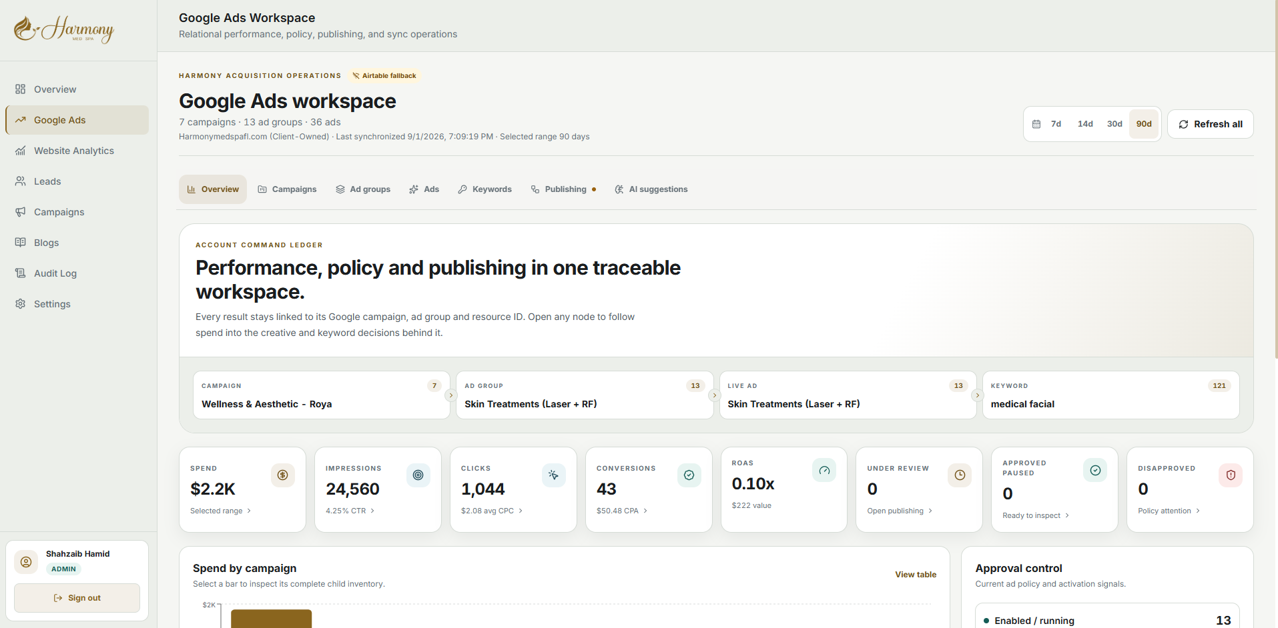
Google Ads workspace inside the dashboard · https://www.crm.harmonymedspafl.com/google-ads
Spend, performance, policy status and publishing sit in one workspace, with every result linked back to its campaign, ad group and keyword.

SERVICE 1 · STEPS 2–3

Treatment-specific landing pages

Ads do not go to the homepage. Each campaign has its own page built for that treatment, so the patient sees exactly what they searched for.
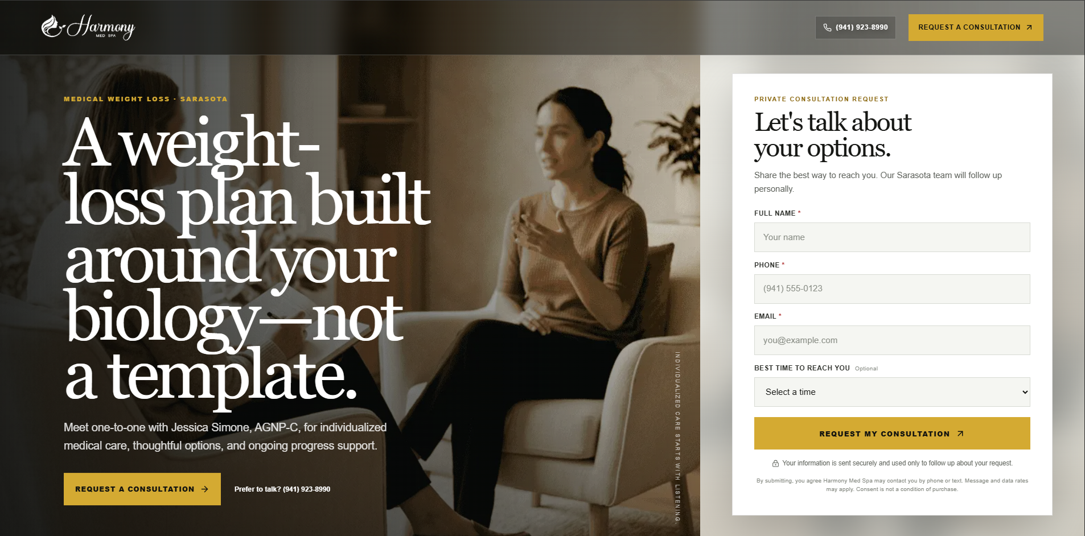
Medical weight loss landing page · https://www.harmonymedspafl.com/landing/medical-weight-loss
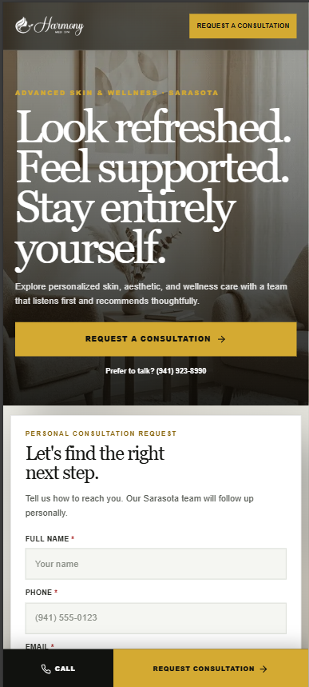
The same page on mobile
What goes into every page
- Headline matches the search that produced the click.
- Form above the fold — no scrolling needed to enquire.
- Provider credibility next to the form: Jessica Simone, AGNP-C.
- Trust marks — BBB Accredited and BNS Best in Business 2024.
- Three-step care pathway and FAQs to remove hesitation.
- Visible phone number for people who prefer to call.
- Mobile-first, with a fixed call and consultation bar.
- Full compliance with Google’s restricted-health advertising rules.

SERVICE 1 · STEP 4

Lead capture into the CRM

The patient enters four fields. The system attaches everything else automatically.

Patient enters | System attaches automatically
Full name | Google click ID (GCLID)
Phone number | Campaign, ad group, keyword, match type
Email address | Source, medium, device, network
Best time to reach | Landing page, full URL, timestamp, treatment interest

- Spam blocked by a hidden honeypot field before it reaches the CRM.
- Phone numbers normalized so messaging works on the first try.
- Duplicates detected and flagged instead of creating two records.
- Conversions only fire after the lead is confirmed received — so ad reporting is never inflated by failed submissions or bots.
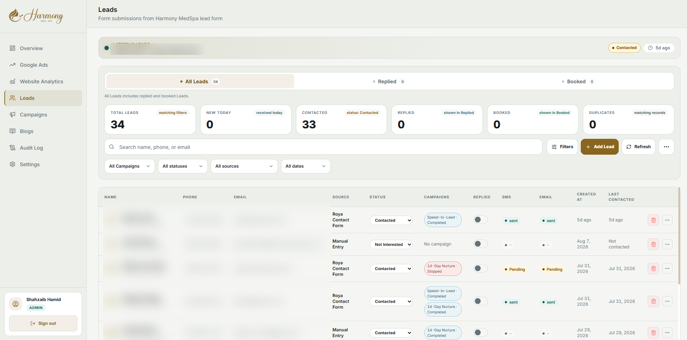
Leads (patient details blurred) · https://www.crm.harmonymedspafl.com/leads
Every lead in one filterable list showing source, status, campaign enrollment, SMS and email delivery, reply status and last contact date.

SERVICE 1 · STEP 5

Speed-to-Lead — SMS and email in 3 seconds

A lead arrives. Before anyone at Harmony has looked at a screen, that person has received a text and an email, both logged against their record.
Harmony’s current average response time: 3 seconds.
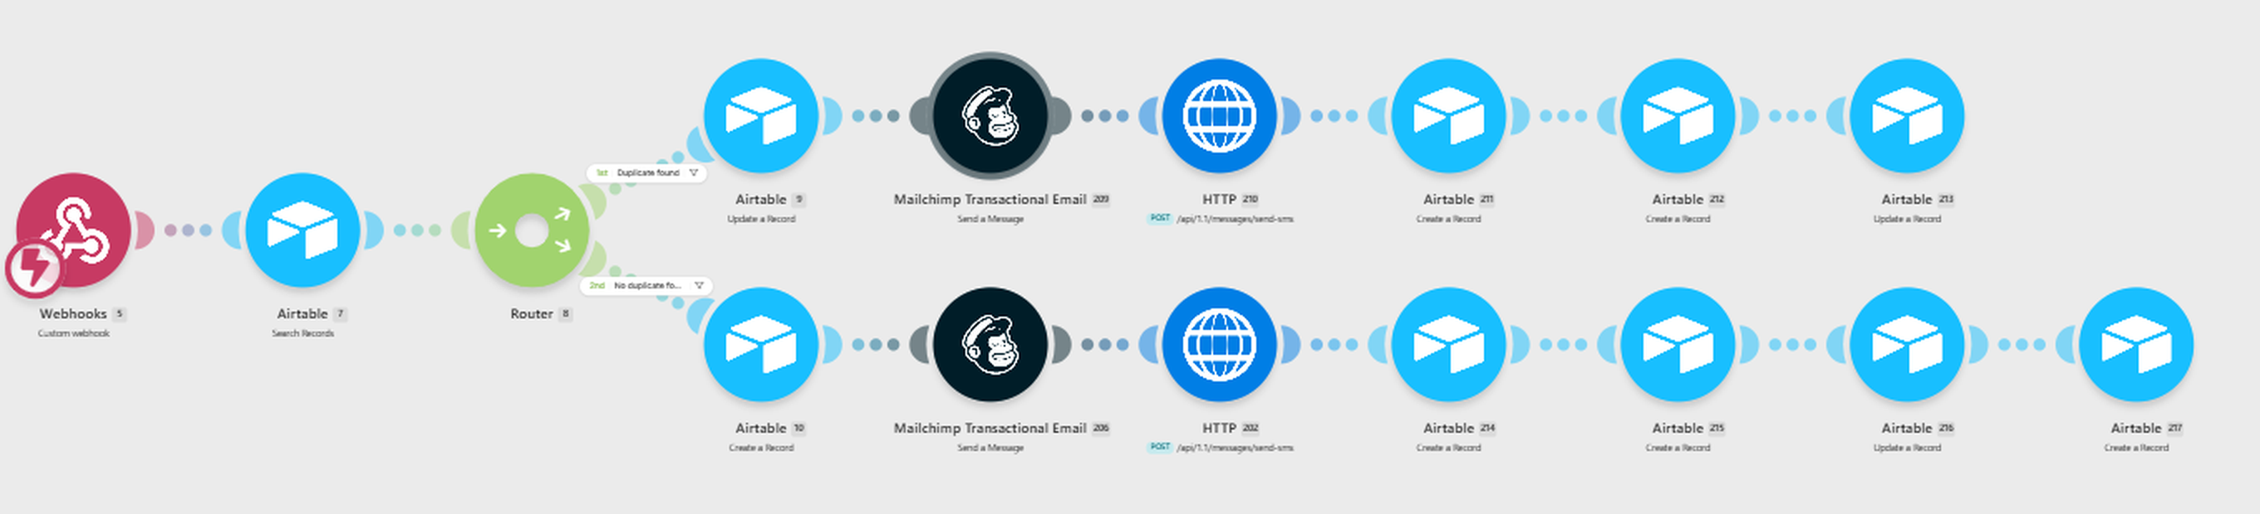
The Speed-to-Lead automation · https://www.crm.harmonymedspafl.com/campaigns/speed-to-lead
Checks for duplicates, routes accordingly, sends both channels, then writes the delivery result of every send back into the system.

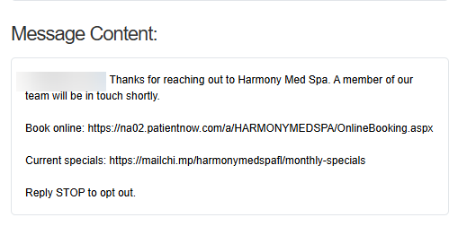
The SMS, sent within seconds
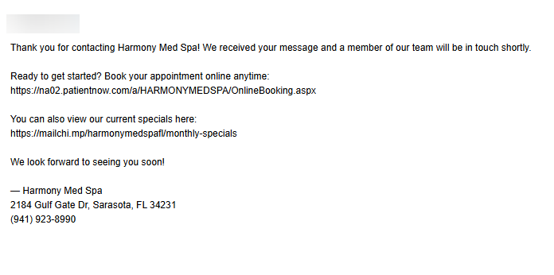
The confirmation email, sent in parallel
- Confirms the enquiry was received.
- Tells them a real person is following up.
- Gives a direct booking link and current specials so they can act now.
- Includes a clear opt-out.

SERVICE 1 · STEP 6

14-Day Campaign if there is no response

Most people do not book on day one. Any lead who does not book or reply is automatically enrolled in five messages over fourteen days, sent personally from Hayden.

When | Channel | What it does
Day 1 | SMS | Personal follow-up with this month’s specials and a booking link
Day 3 | Email | How Harmony approaches care — listening first, no pressure. Handles trust, not price
Day 5 | SMS | Short friendly check-in, repeats the featured offer
Day 8 | Email | Answers the most common hesitation: "I wasn’t sure where to start"
Day 12 | SMS | Final message. Specials ending, booking link, door left open

It stops automatically
The sequence ends the moment the lead books, replies, or their status changes in the CRM. Nobody who has already booked gets chased.

32  ENROLLED | 150  MESSAGES SENT | 30  COMPLETED | 2  AUTO-STOPPED
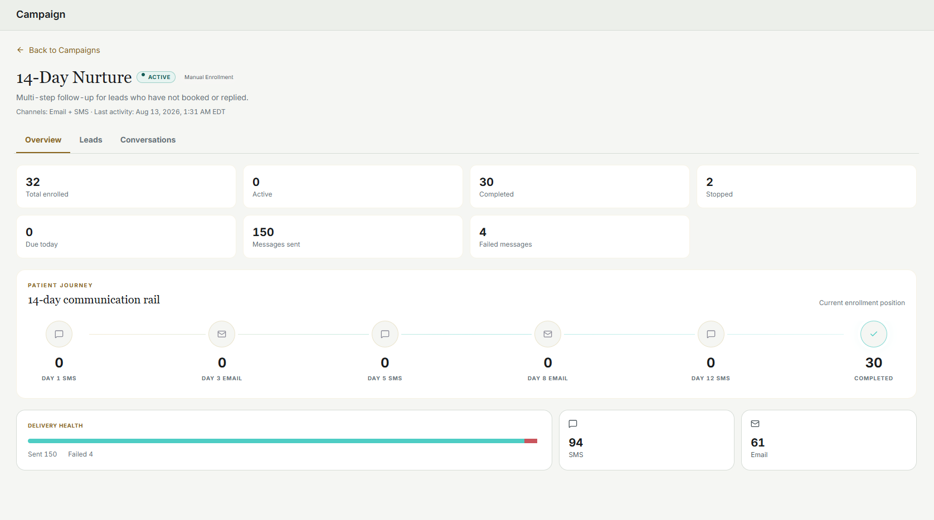
The 14-Day Nurture campaign — the automation runs hourly, sends the right step, logs it and advances · https://www.crm.harmonymedspafl.com/campaigns/14-day-nurture

SERVICE 1 · STEP 7

Appointment booked in PatientNow

Harmony books through PatientNow. We did not replace it — we connected to it.
The moment the form is submitted, the patient sees the live booking calendar. Not a thank-you page. Not "someone will call you."
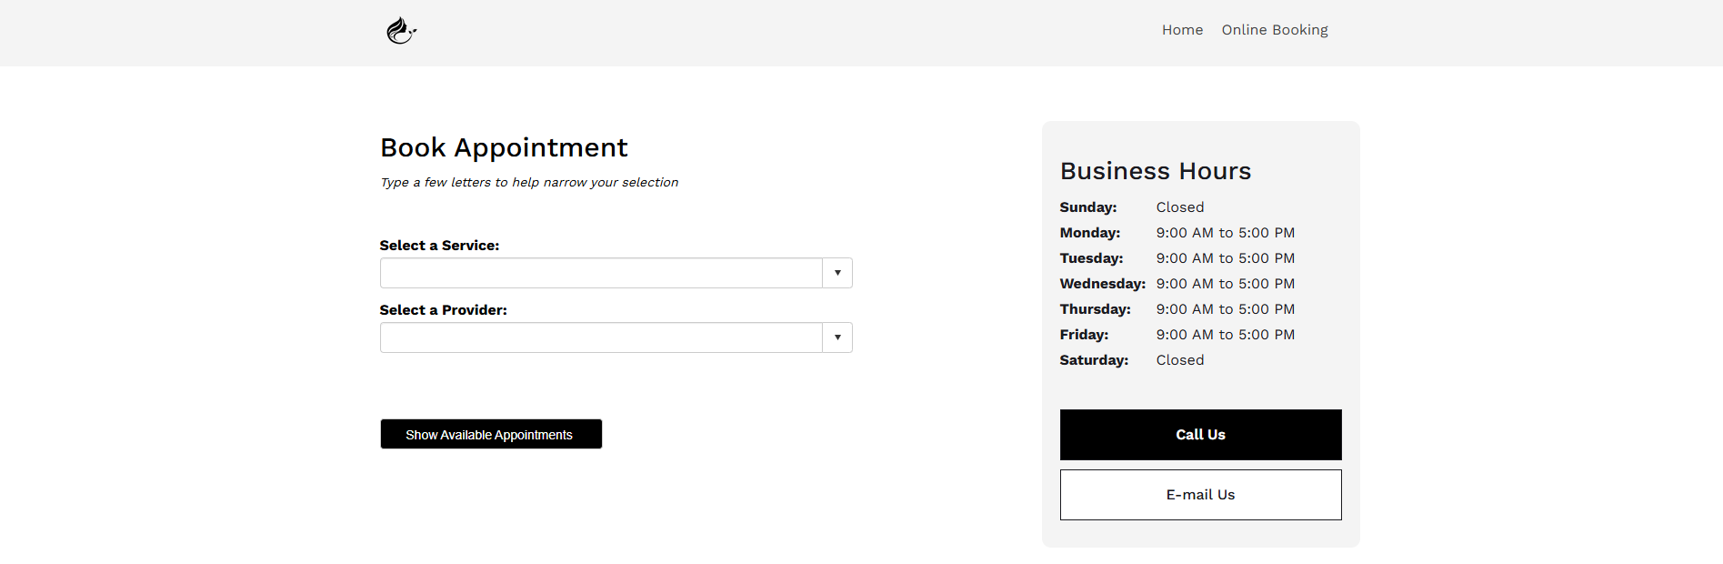
PatientNow online booking, shown immediately after submission
Booking page: https://na02.patientnow.com/a/HARMONYMEDSPA/OnlineBooking.aspx

- Interest is highest at the moment of submission — the path to an appointment is one screen.
- The same booking link is repeated in every automated message afterwards.
- No waiting for a callback, no searching for the phone number again.

Google Analytics inside the CRM
Website traffic, sources, landing page performance and lead events report inside the same dashboard as the leads and campaigns — one place, not three portals.
Live: https://www.crm.harmonymedspafl.com/website-analytics

SERVICE 2

Blog writeup — SEO, AEO and GEO

Paid traffic is rented. Content is owned, and it compounds. Articles are written, optimized and published from inside the CRM, and appear on the live website.
- Search intent first. Written around what patients actually search — treatment comparisons, timelines, patient guides.
- Technical SEO. Meta fields, URL structure and tags prepared automatically from the primary keyword.
- AEO and GEO. Content structured to be quoted by AI search and answer engines, not just ranked by Google.
- Manual control. Nothing publishes automatically. An editor or admin has to click publish and confirm.

Library today: 21 articles · 16 published · 5 in progress.
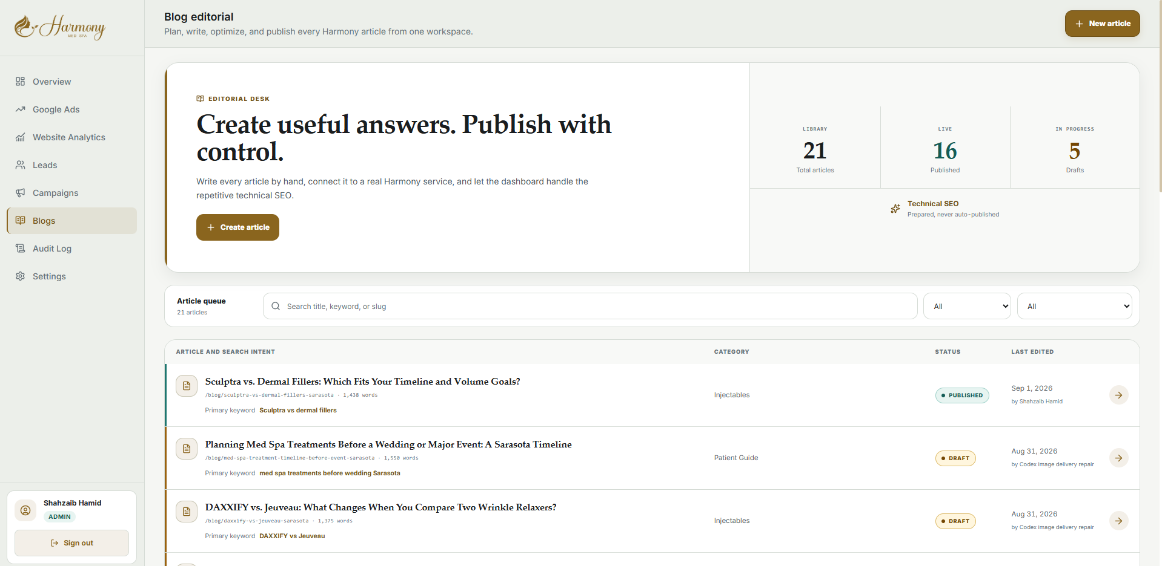
Blog editorial workspace · https://www.crm.harmonymedspafl.com/blogs
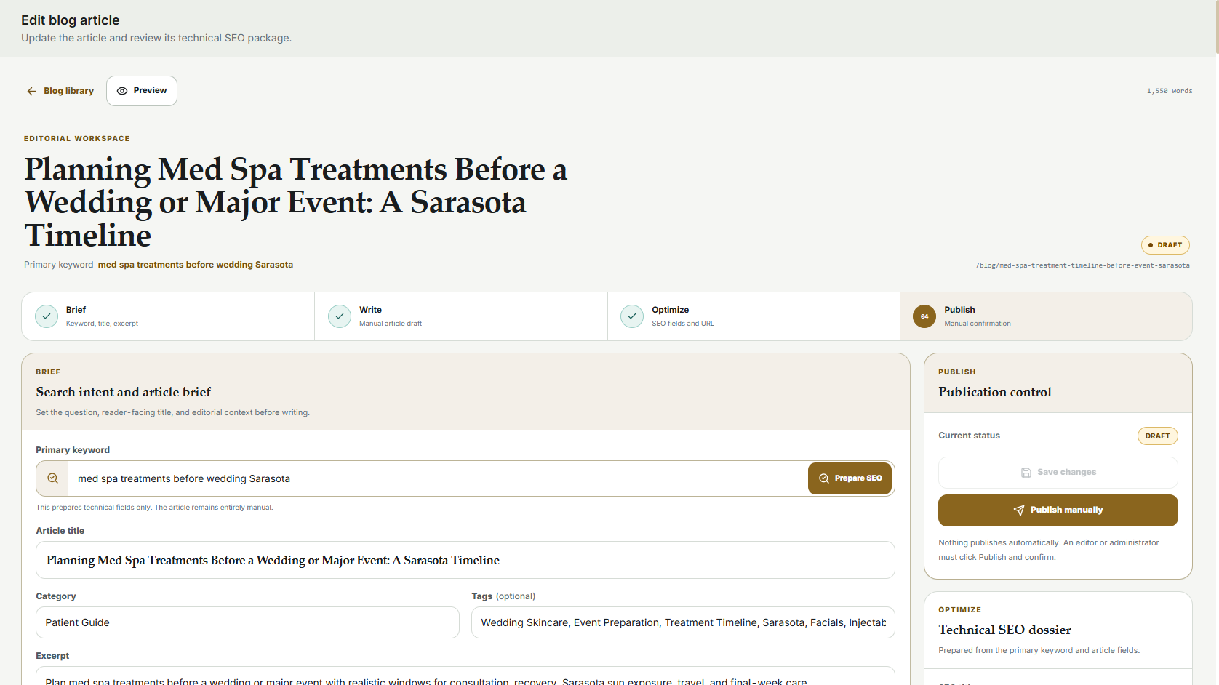
Brief → write → optimize → publish, with the SEO package prepared for each article

SERVICE 3

CRM and website development & maintenance

A custom dashboard and a custom website, both built for Harmony and both maintained by us.
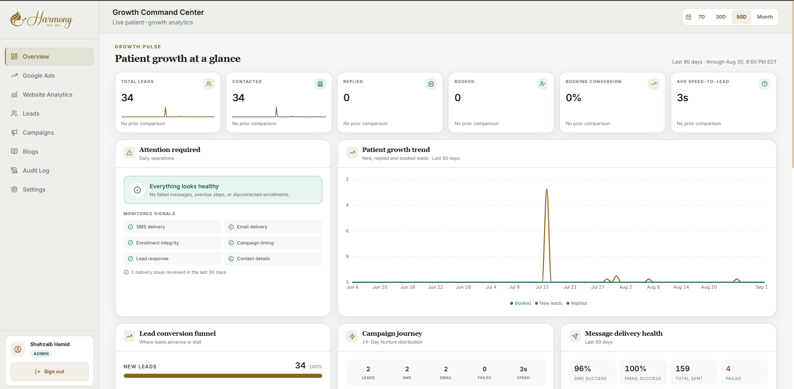
Growth Command Center · https://www.crm.harmonymedspafl.com/
What the dashboard covers
- Leads, statuses, message history and campaign enrollment in one view.
- Both automated campaigns with enrollment and delivery reporting.
- Google Ads workspace — spend, ads, keywords, policy status.
- Website analytics and lead events.
- Blog editorial and publishing.
- Automated health checks on SMS delivery, email delivery, enrollment integrity and campaign timing.
- Role-based staff access and a full audit log of every sign-in and record change.
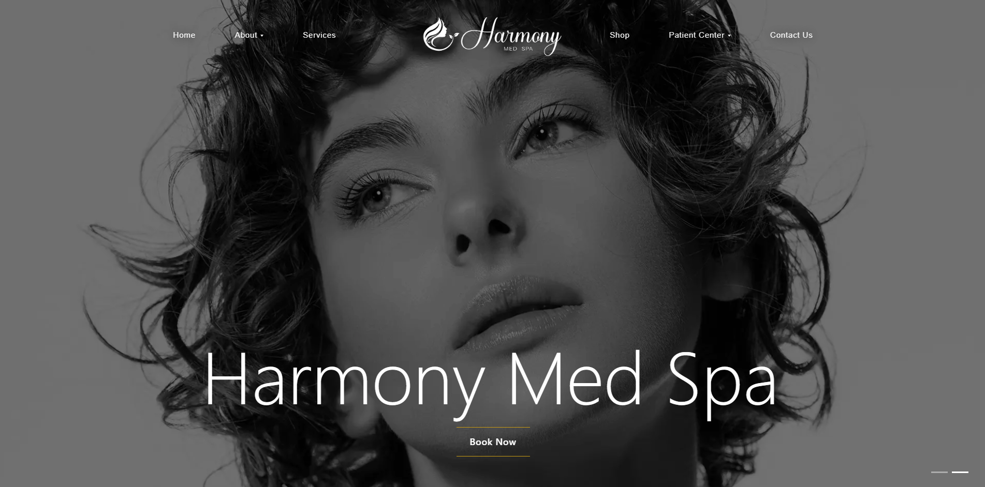
The Harmony Med Spa website · https://www.harmonymedspafl.com/
Service pages, provider pages, patient resources, booking paths and the landing pages the ads point to — custom built, not a template, and maintained continuously.

SERVICE 4

Google Business Profile

- Reviews. Reviews pulled into the dashboard so nothing sits unanswered.
- Replies. Draft replies prepared in the dashboard for staff to approve and post.
- Posts. Profile posts published to keep the listing active.
- Analytics. Local search and profile insights reported alongside campaign and website data.

The local profile is often the first thing a patient sees before they ever reach the website. It is managed as part of the same system rather than left to chance.

What Harmony gets

Outcome | Because
Every lead answered in seconds | Automated SMS and email fire the moment a form is submitted, day or night
No lead forgotten | Anyone who does not book is followed up five times over fourteen days, automatically
Less manual staff work | The system handles repetitive outreach; staff handle real conversations
Marketing is measurable | Every patient traceable to the campaign, ad and keyword that produced them
One operating view | Leads, campaigns, ads, analytics, content and audit in a single dashboard
It scales | A new treatment means a new ad group and landing page — the infrastructure already exists

The stack
Google Ads · Custom website and landing pages · Automation engine · Operational database · Transactional SMS and email · PatientNow booking · Custom CRM dashboard · Google Analytics · Google Business Profile

One deliberate decision worth naming: we did not replace Harmony’s booking system. A growth system should connect what already works, not force a migration that disrupts the clinic for months.

Patient names, phone numbers and email addresses are blurred in every screenshot. Figures are from Harmony Med Spa’s live dashboard, most recent 90-day window.

